
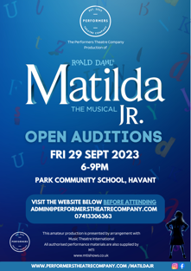
PERFORMERS THEATRE COMPANY

Matilda Jr. Audition form

Please complete all sections.

Child Information
Full Name: |  |  |  | Date:
 | Last | First

Address:

Street Address

 | City |  | Postcode

Date of birth: |  | Year group:

School Name:

Medical Information

Does your child have any allergies? If yes, please give details in the box to the right. | YES | NO

Does your child have asthma? If yes – please state in the box to the right if they have an asthma pump. | YES | NO

Is there anything else you need to tell us about your child with regards to their welfare? If yes, please give details in the box to the right. | YES | NO

Parent/Guardian Information
Parent/  Guardian 1 Full Name: |  |  |  | Date:
 | Last | First

Address:

Street Address

 | City |  | Postcode

Phone: |  | Email:

Relationship to child:

Parent/  Guardian 2 Full Name: |  |  |  | Date:
 | Last | First

Address:

Street Address

 | City |  | Postcode

Phone: |  | Email:

Relationship to child:

Casting information

Important: When arriving at Park Community School, you will be given a sticker with a number on. This will be the order in which you will go in to audition. Once you are called in, you must bring this form with you.
Insert photo of your child below.
Playing age: ___________________

Auditioning for the role of: _______________________

Height: _________

Weight: ________

Shoe size: _______

Declaration

Please confirm you have read the Character Descriptions and are aware of what your child is auditioning for. | YES | NO

Please confirm you have read the Performers Theatre Company Production Code of Conduct, signed by both adult and child. | YES | NO

We take your privacy very seriously as part of our GDPR company policy. We will only use your data to administer your child’s enrollment and to communicate with you about Performers. Please confirm you consent to this. | YES | NO
I agree that I may be considered for a role that is different to the one I originally auditioned for. | YES | NO

Director’s Use only
Acting | Singing
Stage Presence | Any other notes?

Call back:

YES | NO

